LEVERS Name: ______________________
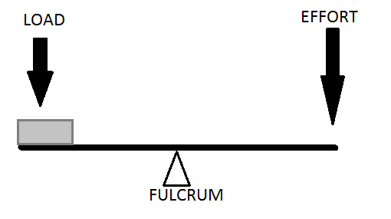
1. Fulcrum is in the centre of the ruler.

Choose the missing word: very easy, not too difficult, quite difficult
It is _______________________________________ to lift the load.

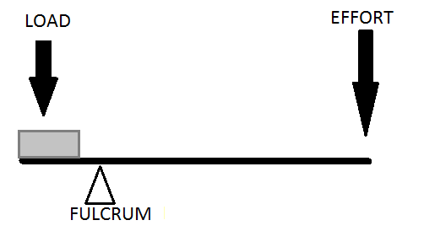
2. Fulcrum is close to the load.

Choose the missing word: very easy, not too difficult, quite difficult
It is _______________________________________ to lift the load.

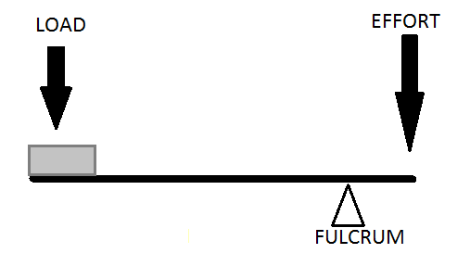
3. Fulcrum is close to the other end of the ruler.

Choose the missing word: very easy, not too difficult, quite difficult
It is _______________________________________ to lift the load.

